Ness LLC Proposal for: 14150 N. Lofton Way Garden City, Idaho 83714 June 11, 2020

What to expect with a Drain Install and Remediation:

- Access is key! We will need admission Monday through Friday, 8 am - 5 pm while the project is in progress. Ness is bonded and insured. It is not necessary for a home owner to be present while the work is being done. Please make sure we have a house key or garage code for entry. The easier the access is for our technicians, the faster the job goes!

- All access to the crawlspace will be protected by plastic sheeting during work.

- The AC unit will need to be off during treatment and for, at least, 3 hours after treatment.

- Installing a drain system is a 14-21day process, depending on drying time. The process CANNOT be rushed or our warranty may be compromised. Please plan accordingly.

- Mold remediation is usually a 7-14 day process, depending on dry times and 3rd party inspection scheduling.

- We carry a 5 year warranty on mold remediation.

- Fans need time to dry the area so we don't always schedule for consecutive days. We try to give as much notice as possible but last minute schedule changes can and do occur. Please direct all questions to ty@nessllc.com

- If a signed bid is returned in the next 24 hours, your estimated start date will be the sometime during the week of July 13th, depending on the completion of the projects already in progress. If there are any opportunities to start sooner, you will be contacted for access.

- We have now extended our warranty for sump pump drainage systems to 10 years!

Highland Homes 6-11-2020 Page 2 of 3
riann@highlandhomesllc.com
PROPOSED WATER DRAINAGE for the crawlspace at 14150 N. Lofton Way Garden City, Idaho 83714
Ness, LLC is an IICRC council certified Mold Remediation Contractor, licensed, bonded, and insured with mold and environmental pollution endorsements
Based on the visual evidence that there is a history of seasonal water intrusion, a partial drain system is recommended in the back half of the crawlspace. This is not a guarantee that there cannot be water intrusion in the front of the crawlspace in the future, as conditions change. There was also some apparent microbial growth noted on the floor decking in sporadic areas. This will need to be cleaned per IICRC guidelines. The vapor barrier is in good condition so we will cut and peel it back in order to install the system. We will then install an apron above the system, pull it up onto the footings and tape seams.
Part 1: Drainage (Digline will be contacted to mark all utilities)
1. All access to crawlspace surfaces will be protected by plastic sheeting during work.
2. Preliminary digging and pumping to remove excess water, as needed.
3. Negative air machine used for the crawlspace during work and for dry down.
4. Additional fans will be installed for dry down, as needed.
5. Cut and remove approx. 8" of the bottom of the insulation where it's damaged. There will be no need to replace this as it is extra overhanging insulation.
6. Clear air vents of any insulation that may be blocking air flow.
Part 2:
1. Install a fabric lined graded drain system below the bottom of the footings on the perimeter in the back half of the crawlspace.
2. Drain in crawlspace will collect into a sump tank. The sump tank will be in the back middle area.
Part 3: Install sump pump into tank with insulated lid in the appropriate determined area. Sump will discharge through a drain line to a dispersal bed towards the front left landscaped area. (The sump pump discharge line will not be visible from the outside of the house. Installation of electrical outlet with audible alarm and manual shut-off included.)
Total Labor & Materials Parts 1-3 = $4,660.38

Part 4: Mold Remediation
1. All access to the crawlspace will be protected during work.
2. Containment will be set at the crawlspace access.
3. The furnace system is to remain off during the work and for three hours after each treatment.
4. Hepa filtered negative air flow will be ongoing during the project
5. Remove any insulation from the area where work is to be performed.
6. Surface cleaning and abrasion removal, as needed and treat impacted floor decking. (See Part 5)
7. Push back insulation where removed.
8. Clear all vents of any insulation or debris that may be obstructing air flow.
Part 5: Microbial Growth Remediation
After containment is set up, then surface cleaning and abrasive removal, as needed, of visible microbial growth on the impacted floor decking. Once mold impacted surfaces are cleaned, then treat the remediated surfaces in the crawlspace with a non-toxic Microbial Growth Inhibitor. Procedures are established from IICRC S520 Standard and Reference Guide for Professional Mold Remediation. (2) All work in the crawlspace will be performed using accepted procedures. (3) Respiratory Protection is in accordance with the OSHA respiratory protection standard (29 CFR 1910.134) for the remediation. Gloves, full-face respirators, p-100 particulate filters, Tyvek full body suits with hoods and boots. Photo documentation of work performed is available at the end of the project upon prior request. Disposal of debris.

Total Labor & Materials Parts 4-5 = $1,887.12 (This price only good if done with drain system)

Highland Homes 6-11-2020 Page 3 of 3

Part 6: Mandatory 3rd Party Certified mold inspector’s visual inspection and documentation.
**Final Clearance Air Testing not included in protocol or scope** ADD to Total $185.00

Part 7: Remove and dispose of miscellaneous debris and building materials. Install new 6 mil. vapor barrier apron on the perimeter above the system in the back half of the crawlspace. Pull apron up onto the footings, where possible, and tape seams per code for a conditioned crawlspace. ADD to Total $436.18
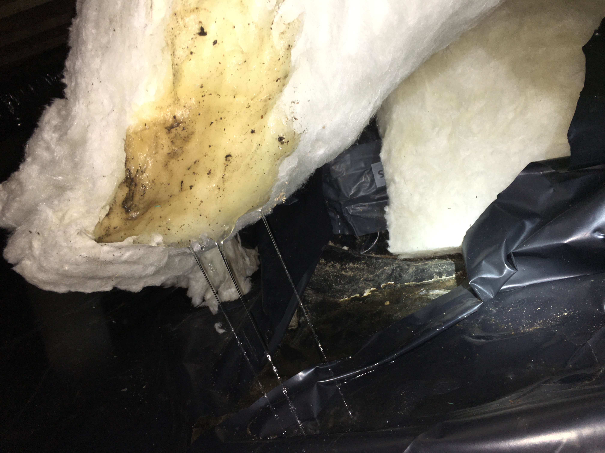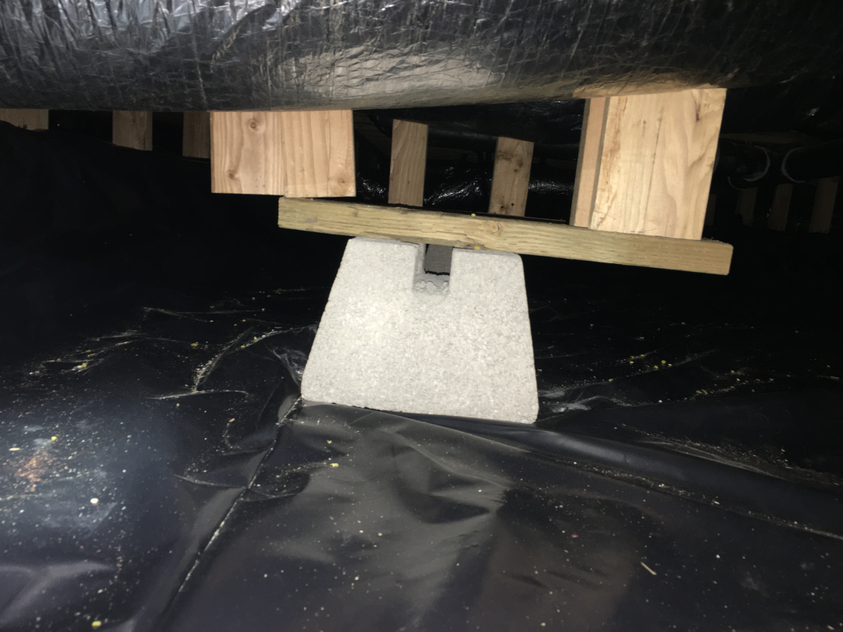
Damaged/wet insulation to be removed Highland Homes will need to address the supports

>> To be paid in full upon completion <<
>> 3% charge on credit card transactions <<

Parts 1-3 Accepted by: _______________________________________________________ Date ________________

Parts 4-5 Accepted by: _______________________________________________________ Date _________________

Part 6 Accepted by: _________________________________________________________ Date _________________

Part 7 Accepted by: _________________________________________________________ Date _________________

Print Name: _________________________________________________________________________________
Douglas A. Ness (CMRS) -Idaho Contractor Registration# RCE-481

Ness, LLC gives a 10 Year Warranty on sump pump, drain system for no standing water (as per signed contract) on the crawlspace floor where drain was installed from ground water seepage, and rain/snow. This Warranty is Transferable to new home buyer within warranty period. Drainage Warranty excludes water standing on the crawlspace floor from flooding that is not part of ground water seepage from irrigation or rain or due to, interior home appliances or plumbing leaks. Furthermore, Ness, LLC is not responsible for any future landscape changes that may disrupt the system. A Service Charge applies for non-warranty issues.
Work under this proposal is limited to the items listed. Any additional work will need to be outlined and set out by a separate contract, or have the contract amended and signed to reflect any additional work desired.

Ness LLC gives a 5-year limited warranty on no visible microbial re-growth where work is done. Warranty is void if any water or water source introduced into the area. After the treatment procedures, mold will not grow if there is no additional water source.

