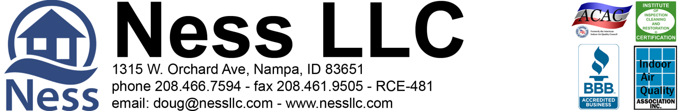

Christine McKinney, 208-724-4051 6-11-2020 Page 1 of 1
cmmac.41@gmail.com

PROPOSED WATER DRAINAGE for the Basement at 1522 E. Warm Springs Ave. Boise, Idaho 83712

Part A: Due to the age of the driveway, underground plumbing, and basement wall, Ness is not responsible for any plumbing leaks or breaks that may occur during the project. Also, we cannot warranty the integrity of the concrete on the basement wall or the driveway. This has to be understood and signed off before we can do the work.

Scope of work:
1. Cut the concrete from the driveway from approximately the back left window well to approx. 4 feet beyond the back left corner of the house. The cut will be approximately 3-4 feet out from the basement wall. Demolish the cut concrete and remove it from premises. Removed ground cover as needed. (Note: Ness will not replace any of the soils coverings or concrete - there will have to be a contractor to determine the next scope at that time after excavation and backfill is done).
2. Excavate down to the bottom of the footing.
3. Install a drain system at the bottom of the footing graded and drained to the drywell to be installed.
4. Seal the outside exposed basement wall, and install drain-x drain plain on the wall.
5. Back fill the excavated area.
6. Install a dry well next to the basement wall up to 5 feet below the foundation. Install 12" perforated pipe, line the pit with fabric, back fill with drain material, install an access lid, and bring soils to the top of the lid to the surface. Lid will be placed just below the surface so it can be accessed.
7. We will level the excavated area when we are done.

Total Labor and materials Parts 1-7 -- $8,715.00

>> 60% down and 40% paid upon completion <<
>> 3% charge on credit card transactions <<

Part A accepted: ____________________________________________ Date ____________________

Parts 1-7 accepted: ___________________________________________ Date ____________________

***If a signed bid is returned within the next 24 hours, your estimated start date will be during the week of July 22nd.

