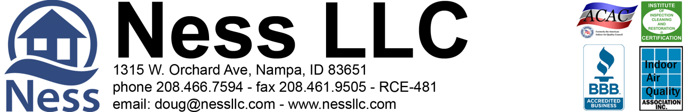

Ness LLC Proposal for: 11799 Sailing Hawk Star, Idaho 83669 6-1-2020

What to expect with a Mold Remediation Project:

- Access is key! We will need admission Monday through Friday, 8 am - 5 pm while the project is in progress. Ness is bonded and insured. It is not necessary for a home owner to be present while the work is being done. If you are comfortable with it, please make sure we have a house key or garage code for entry. The easier the access is for our technicians, the faster the job goes!

- All access to the affected areas will be protected by plastic sheeting during work.

- Mold Remediation in attics must be done in the early morning hours due to the rising heat in the summer.

- Mold remediation will typically take 5-7 days and sometimes 5-10 workings days, depending on the scope of work and scheduling.

- Fans need time to dry the area. We don't always schedule for consecutive days. We try to give as much notice as possible but last minute schedule changes can and do occur.

- Please note: We are almost three weeks out in scheduling new projects. If a signed contract is returned within 24 hours, your estimated start date will be some time during the week of June 15th. Please plan accordingly. If there are any cancellations, you will be moved up in the schedule and contacted for access.

Sunrise Homes 6-1-2020 Page 2 of 2
russbundy@yahoo.com

RESTORATION PROPOSAL for the crawlspace at 11799 Sailing Hawk Star, Idaho 83669
Ness, LLC is an IICRC council certified Mold Remediation Contractor, licensed, bonded, and insured with mold and environmental pollution endorsements.
As requested, the crawlspace was inspected only for mold. There appears to be sporadic microbial growth throughout the crawlspace on the top and bottom cords of the floor joists. Remediation will be needed. Please note that once remediated, new mold will not grow unless there is a water source introduced. (See warranty in the footer of the proposal)

Part 1: Mold Remediation
- All access to crawlspace will be protected during work.
- Containment will be set at the crawlspace access.
- Hepa filtered negative air flow will be ongoing during the project.
- The HVAC/AC system is to remain off during the work and for 4 hours after each treatment.
- Set up dehumidifier to aid in dry down.
- Remove insulation in the area where work is to be done, if necessary.
- Surface cleaning and abrasive removal as needed of visible microbial growth on the impacted top and bottom cords of the floor joists. (See Part 2)
- Put back existing insulation, as needed.
- Clear air vents of any debris that may be blocking air flow.
Part 2: Microbial Growth Remediation
- After containment is set up, then perform surface cleaning and abrasive removal as needed of visible microbial growth on the impacted top and bottom cords. Once all visible mold is removed from impacted surfaces and inspected, we will then do the final treatment of the remediated surfaces in the crawlspace with a non-toxic Microbial Growth inhibitor.)
- (1) Procedures are established from IICRC S520 Standard and Reference Guide for Professional Mold Remediation. (2) All work in the crawlspace will be performed using accepted procedures. (3) Respiratory Protection is in accordance with the OSHA respiratory protection standard (29 CFR 1910.134) for the remediation. Gloves, full-face respirators, p-100 particulate filters, Tyvek full body suits with hoods and boots.
- Photo documentation of work performed is available at the end of the project upon prior request. Disposal of debris.
Total Labor & Materials Parts 1-2 = $2,649.13

Part 3: Recommended: 3rd Party Certified mold inspector’s visual inspection and documentation.
**Final Clearance Air Testing not included in protocol or scope.** ADD to Total $185.00

>> To be paid in full upon completion <<
>> 3% charge on credit card transactions <<

Parts 1-2 Accepted by: _____________________________________________________ Date _________________

Part 3 Accepted by: _______________________________________________________ Date _________________

Please print name: _______________________________________________________________________________
Douglas A. Ness (CMRS) -Idaho Contractor Registration# RCE-481

