Ness LLC Proposal for: 1114 S. Gem Stone Way Emmett, Idaho June 4, 2020

What to expect with a Drain Install?

- Access is key! We will need admission Monday through Friday, 8 am - 5 pm while the project is in progress. Ness is bonded and insured. It is not necessary for a homeowner to be present while the work is being done. Please make sure we have a house key or garage code for entry. The easier the access is for our technicians, the faster the job goes!

- All access to the crawlspace will be protected by plastic sheeting during work.

- Please plan to have all pets in a secure area while our technicians are onsite. This is for everyone’s safety.

- Installing a drain system is a 14-21day process, depending on drying time. The process CANNOT be rushed, or our warranty may be compromised. Please plan accordingly.

- Fans need time to dry the area, so we do not always schedule for consecutive days. We try to give as much notice as possible but last-minute schedule changes can and do occur. Please direct all questions to ty@nessllc.com

- We are currently 3-4 weeks out in starting new projects. If a signed contract is returned within 24 hours, your estimated start date will be during the week of June 29th. If any cancellations occur, you will be moved up in the schedule and contacted for access.

- We have now extended our warranty for sump pump drainage systems to 10 years!

Michael Taylor, 208-284-0771 6-4-2020 Page 2 of 3
mtaylor@baremeralstandard.com
PROPOSED WATER DRAINAGE for the Crawlspace at 1114 S. Gem Stone Way Emmett, Idaho
As requested, we inspected the crawlspace for standing water. Based on the visual evidence that there is a history of water intrusion and up to 4” of standing water throughout, we recommend an interior perimeter drain system with 2 sump pumps. Because of the amount of water, access and view was limited. Mold growth is highly likely in these conditions due to the humidity. Dehumidifiers will be required and if any microbial growth and/or water damage is observed during the install, you will be informed immediately, and a bid will be provided. The vapor barrier also will need to be replaced.

Part 1: Drainage (Digline will be contacted to mark all utilities)
1. All access to crawlspace surfaces will be protected by plastic sheeting during work.
2. Preliminary digging and pumping to remove excess water, as needed.
3. Negative air machine used for the crawlspace during work and for dry down.
4. Additional fans and dehumidifiers will be installed for dry down, as needed.
5. Clear crawlspace vents of any insulation that may be blocking air flow.
Part 2:
1. Install a fabric lined graded drain system below the bottom of the footings along the interior perimeter of the crawlspace except for behind the garage.
2. Drain in crawlspace will collect into two sump tanks. One sump tank will be in the front of the crawlspace and the other will be in the back-left area.
Part 3: Install sump pumps into tanks with insulated lids in the appropriate determined areas. The sumps will discharge through a drain line to a dispersal bed towards a landscaped area that will be determined onsite. (The sump pump discharge line will not be visible from the outside of the house. Installation of electrical outlet with audible alarm and manual shut-off included.)
Total Labor & Materials Parts 1-3 = $5,938.72

Part 4: Remove and dispose of old vapor barrier, miscellaneous debris, and building materials. Install new 6 mil. vapor barrier in the entire crawlspace and pull up onto the footings, where possible. Total Labor & Materials Part 4 = $775.00

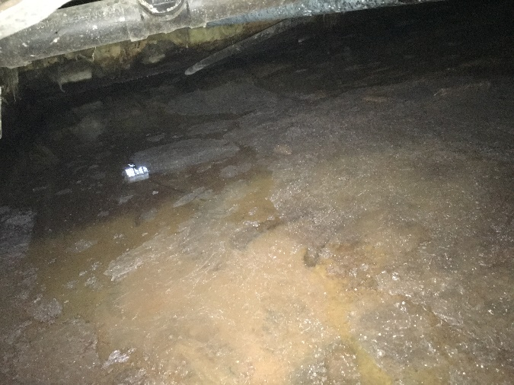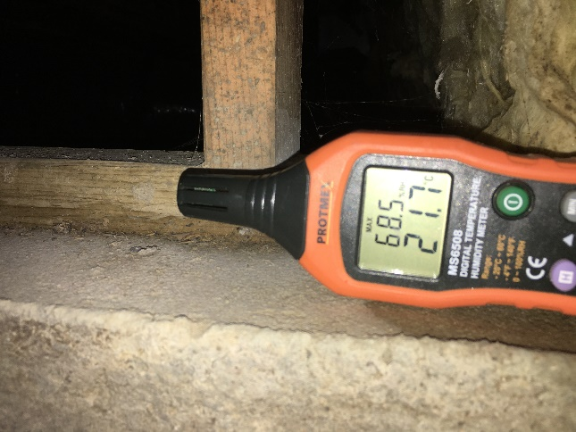
Standing water High humidity

Michael Taylor, 208-284-0771 6-4-2020 Page 3 of 3

>> 50% down, 50% due on completion <<
>> 3% charge on credit card transactions <<

Parts 1-3 Accepted by: ____________________________________________________ Date ________________

Part 4 Accepted by: _______________________________________________________ Date _______________

Please print name: ________________________________________________________________________________
Douglas A. Ness (CMRS) -Idaho Contractor Registration# RCE-481

Ness, LLC gives a 10 Year Warranty on sump pump, drain system for no standing water (as per signed contract) on the crawlspace floor where drain was installed from ground water seepage, and rain/snow. This Warranty is Transferable to new home buyer within warranty period. Drainage Warranty excludes water standing on the crawlspace floor from flooding that is not part of ground water seepage from irrigation or rain or due to, interior home appliances or plumbing leaks. Furthermore, Ness, LLC is not responsible for any future landscape changes that may disrupt the system. A Service Charge applies for non-warranty issues.
Work under this proposal is limited to the items listed. Any additional work will need to be outlined and set out by a separate contract, or have the contract amended and signed to reflect any additional work desired.

