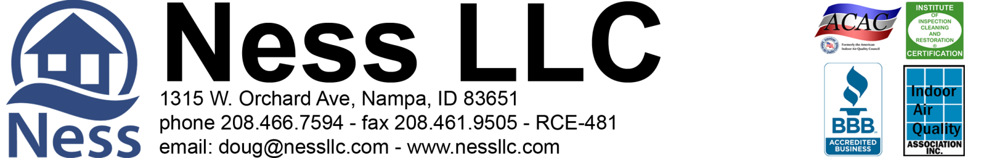

Tresidio Homes, Attn: Tom Waters 6-3-2020 Page 1 of 1
tom@tresidio.com
PROPOSED Remediation for the Crawlspace at 7091 N. Exeter Pl. Meridian, Idaho 83646
Ness, LLC is an IICRC council certified Mold Remediation Contractor, licensed, bonded, and insured with mold and environmental pollution endorsements.
There is visible mold in the early stages of growth. This was likely present and dormant when the drain system was started. As conditions changed in the crawlspace, new growth was triggered. Remediation will be needed.

Part 1: Mold Remediation
- All access to crawlspace will be protected during work.
- Containment will be set at the crawlspace access.
- Hepa filtered negative air flow will be ongoing during the project.
- The HVAC/AC system is to remain off during the work and for 4 hours after each treatment.
- Remove insulation in the area where work is to be done, if necessary.
- Surface cleaning and abrasive removal as needed of visible microbial growth on the impacted floor joists and pony walls.
(See Part 2)
- Put back existing insulation, as needed.
- Clear all air vents of insulation and/or debris
Part 2: Microbial Growth Remediation
- After containment is set up, then perform surface cleaning and abrasive removal as needed of visible microbial growth on the impacted floor joists and pony walls. Once all visible mold is removed from impacted surfaces and inspected then do the final treatment of the remediated surfaces in the crawlspace with a non-toxic Microbial Growth inhibitor.)
- (1) Procedures are established from IICRC S520 Standard and Reference Guide for Professional Mold Remediation. (2) All work in the crawlspace will be performed using accepted procedures. (3) Respiratory Protection is in accordance with the OSHA respiratory protection standard (29 CFR 1910.134) for the remediation. Gloves, full-face respirators, p-100 particulate filters, Tyvek full body suits with hoods and boots.
- Photo documentation of work performed is available at the end of the project upon prior request. Disposal of debris.

Total Labor & Materials Parts 1-2 = $2,151.32

Part 3: Recommended: 3rd Party Certified mold inspector’s visual inspection and documentation.
**Final Clearance Air Testing not included in protocol or scope** ADD to Total $185.00

>> To be paid in full upon completion << >> 3% charge on credit card transactions <<

Parts 1-2 Accepted by: ____________________________________________________ Date ________________

Part 3 Accepted by: _______________________________________________________ Date _________________

Please print name: ________________________________________________________________________________
Douglas A. Ness (CMRS) -Idaho Contractor Registration# RCE-481

Ness LLC gives a 5 year limited warranty on no visible microbial re-growth where work is done. Warranty is void if any water or water source introduced into the area. Work under this proposal is limited to the items listed. Any additional work will need to be outlined and set out by a separate contract, or have the contract amended and signed to reflect any additional work desired.

