Ness LLC Proposal for: 13012 W. Ventana Dr. Boise, Idaho 83713 June 9, 2020

What to expect with a Drain Install:

- Access is key! We will need admission Monday through Friday, 8 am - 5 pm while the project is in progress. Ness is bonded and insured. It is not necessary for a home owner to be present while the work is being done. Please make sure we have a house key or garage code for entry. The easier the access is for our technicians, the faster the job goes!

- All access to the crawlspace will be protected by plastic sheeting during work.

- Installing a drain system is a 14-21 day process, depending on drying time. The process CANNOT be rushed or our warranty may be compromised. Please plan accordingly.

- Fans need time to dry the area so we don't always schedule for consecutive days. We try to give as much notice as possible but last minute schedule changes can and do occur. Please direct all questions to ty@nessllc.com

- If a signed contract is returned within 24 hours, your estimated start date will be during the week of July 6th. Payment may be held in escrow if needed. You will be contacted for access if there are any cancellations and we're able to move you up on the schedule.

- We have now extended our warranty for sump pump drainage systems to 10 years!

Paula and Richard Weathers 6-9-2020 Page 2 of 3
weatherspaula@gmail.com

PROPOSED WATER DRAINAGE for the Crawlspace at 13012 W. Ventana Dr. Boise, Idaho 83713
As requested, we inspected the crawlspace for standing water. Based on the visual evidence that there is a history of the water intrusion, a partial drain system is recommended. This is not a guarantee that there cannot be future intrusion in other areas as conditions change. There did not appear to be any visible microbial growth, at this time, but the view was limited due to standing water in some areas. If any microbial growth is discovered, while the recommended work is performed, you will be informed immediately and a bid will be provided for remediation. The vapor barrier is in poor condition and will need to be replaced. There is also a void around the sewer line that has settled and will need to be backfilled and compacted.

Part 1: Drainage (Digline will be contacted to mark all utilities)
1. All access to crawlspace surfaces will be protected by plastic sheeting during work.
2. Preliminary digging and pumping to remove excess water, as needed.
3. Negative air machine used for the crawlspace during work and for dry down.
4. Additional fans will be installed for dry down, as needed.
5. Clear foundation vents of any insulation that may be blocking air flow.
Part 2:
1. Install a fabric lined graded drain system below the bottom of the footings along the interior perimeter of the crawlspace as specified. The trenching will run down the left side of the crawlspace, run across the entire back and about half-way up the right side from the back corner.
2. Drain in crawlspace will collect into a sump tank located in the back-middle area of the crawlspace.
Part 3: Install sump pump into tank with insulated lid in the appropriate determined area. Sump will discharge through a drain line to a dispersal bed towards a landscaped area on the front right side of the home. (The sump pump discharge line will not be visible from the outside of the house. Installation of electrical outlet with audible alarm and manual shut-off included.)
Total Labor & Materials Parts 1-3 = $5,448.72

Part 4: Remove and dispose of old vapor barrier, miscellaneous debris, and building materials in the right bay where the system will be installed. Install new 6 mil. vapor barrier, where removed, and pull up onto the footings, where possible. ADD to Total = $768.31

Part 5: Haul approx. 20 bags of soil into the crawlspace. Backfill area around the sewer line. This is to be compacted and graded towards the drain system. ADD to Total = $420.00

Paula and Richard Weathers 6-9-2020 Page 3 of 3

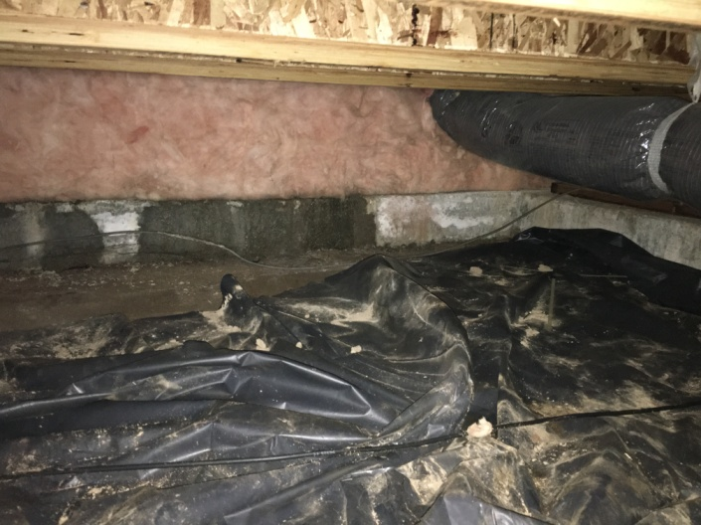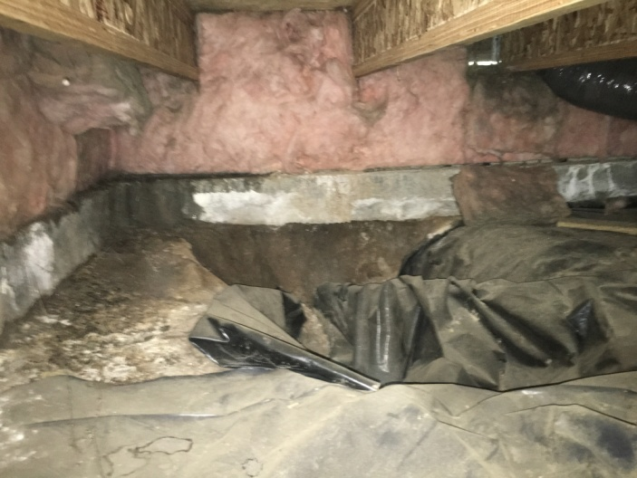
evidence of water through cold joint voided area around sewer line

>> Paid out of closing as long as closing is within 21 days of job completion or 50% down and 50% paid upon completion <<
>> 3% charge on credit card transactions <<

Parts 1-3 Accepted by: _____________________________________________________ Date ________________

Part 4 Accepted by: _______________________________________________________ Date _______________

Part 5 Accepted by: _______________________________________________________ Date _______________

Please print name: ________________________________________________________________________________
Douglas A. Ness (CMRS) -Idaho Contractor Registration# RCE-481

Ness, LLC gives a 10 Year Warranty on sump pump, drain system for no standing water (as per signed contract) on the crawlspace floor where drain was installed from ground water seepage, and rain/snow. This Warranty is Transferable to new home buyer within warranty period. Drainage Warranty excludes water standing on the crawlspace floor from flooding that is not part of ground water seepage from irrigation or rain or due to, interior home appliances or plumbing leaks. Furthermore, Ness, LLC is not responsible for any future landscape changes that may disrupt the system. A Service Charge applies for non-warranty issues. Work under this proposal is limited to the items listed. Any additional work will need to be outlined and set out by a separate contract, or have the contract amended and signed to reflect any additional work desired.

