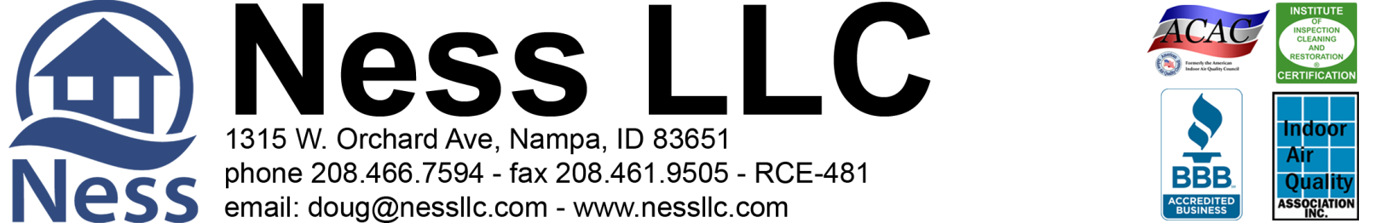

Ness LLC Proposal for: 2000 E. Mackay Dr. Meridian, Idaho July 14, 2020

What to expect with a Mold Remediation Project:

- Access is key! We will need admission Monday through Friday, 8 am - 5 pm while the project is in progress. Ness is bonded and insured. It is not necessary for a home owner to be present while the work is being done. If you are comfortable with it, please make sure we have a house key or garage code for entry. The easier the access is for our technicians, the faster the job goes!

- All access to the affected areas will be protected by plastic sheeting during work.

- Mold remediation will typically take 5-7 days and sometimes 5-10 workings days, depending on the scope of work and scheduling.

- We don't always schedule for consecutive days. This is a normal part of our process. Fans may need to run an extra day or two to dry down surfaces and atmosphere.

- It is stated in the bid to shut off the furnace and leave it off for, at least, 3 hours after each treatment. This is to prevent the odor of our treatment product from getting in the duct system and traveling through the house. The smell is unpleasant but not harmful.

- If a signed bid is returned within 24 hours, your estimated start date will be some time during the week of August 17th.

Brandon Page 7-14-2020 Page 2 of 2
brandonpage@live.com

RESTORATION PROPOSAL for the Crawlspace at 2000 E. Mackay Dr. Meridian, Idaho 83642
Ness, LLC is an IICRC council certified Mold Remediation Contractor, licensed, bonded, and insured with mold and environmental pollution endorsements.
As requested, we inspected the crawlspace for water intrusion and mold. There did not appear to be enough evidence to justify installing a drain system at this time. We would recommend closely monitoring the area for any changes and have it re-evaluated in 2-3 months. There did appear to be some visible mold on the floor decking under the kitchen. Remediation will be needed. The vapor barrier is also in poor condition and needs replacement. See our recommended scope of work below.

Part 1: Crawl Space Scope of Work
- All access to the crawlspace will be protected during work.
- Containment will be set at the crawlspace access.
- The furnace/AC system is to remain off during the work and for three hours after each treatment.
- Hepa filtered negative air flow will be ongoing during the project.
- Surface cleaning and abrasion removal, as needed, and treat impacted floor decking under the kitchen.(See Part 2)
- Clear all vents of any insulation or debris that may be obstructing air flow
Part 2: Microbial Growth Remediation
- After containment is set up, then surface cleaning and abrasive removal, as needed, of visible microbial growth on the impacted floor decking. Once mold impacted surfaces are cleaned, then treat the remediated surfaces in the crawlspace with a non-toxic Microbial Growth Inhibitor.
- (1) Procedures are established from IICRC S520 Standard and Reference Guide for Professional Mold Remediation. (2) All work in the crawlspace will be performed using accepted procedures. (3) Respiratory Protection is in accordance with the OSHA respiratory protection standard (29 CFR 1910.134) for the remediation. Gloves, full-face respirators, p-100 particulate filters, Tyvek full body suits with hoods and boots.
- Photo documentation of work performed is available at the end of the project upon prior request. Disposal of debris.
Total Labor & Materials Parts 1 - 2 ---- $1,493.21

Part 3: Mandatory 3rd Party Certified mold inspector’s visual inspection and documentation.
**Final Clearance Air Testing not included in protocol or scope. ** ADD to Total $185.00

Part 4: Remove and dispose of old vapor barrier, miscellaneous debris, and building materials. Install new 6 mil. vapor barrier in the
entire crawlspace up onto the footings, where possible. ADD to Total $ 523.68

>> Paid out of closing as long as closing is within 21 days of job completion or 50% down and 50% paid upon completion <<
>> 3% charge on credit card transactions <<
Parts 1-2 Accepted by: _______________________________________________________ Date _________________

Part 3 Accepted by: _________________________________________________________ Date _________________

Part 4 Accepted by: _________________________________________________________ Date _________________

Please Indicate Payment Schedule: (check payment option) 50/50 Out of Closing

Please print name: _______________________________________________________________________________
Douglas A. Ness (CMRS) -Idaho Contractor Registration# RCE-481

