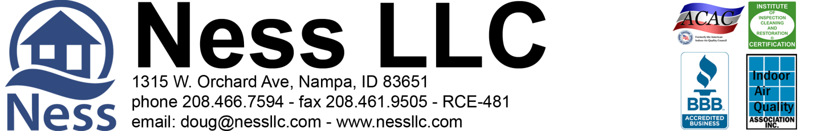

Rick Chromey, 208-914-1404 8-25-2020 Page 1 of 1
rickchromey@gmail.com

PROPOSED Dry Down/Warranty Work for the crawlspace at 299 N. Hullen Pl. Star, Idaho 83669
Ness, LLC is an IICRC council certified Mold Remediation Contractor, licensed, bonded, and insured with mold and environmental pollution endorsements.
Flooding occurred due to irrigation in the canal that was left running for too long. The entire system worked as designed but was not able to keep up with the volume of this magnitude due to the oversaturation of the surrounding soils. Once the water dissipated, the system was then able to keep up as demonstrated during our inspection. We have replaced the pump under warranty and will set dry down equipment as a courtesy. There was some damage to the discharge line and surrounding area that will need to be repaired as detailed below.

Part 1: Warranty
- Pump was already replaced under warranty due to excessive wear.
- Preliminary digging and pumping to remove excess water, as needed.
- Set up negative air machine and 2 additional fans for dry-down: up to 14 days.
- Remove equipment in 14 days, dispose of debris.
- Clear all vents for proper air flow

Total Labor & Materials Part: 1 = No Charge/Warranty
(Normal value = $2,800.00)

Part 2: Recommendations- Not covered under warranty
- Haul bagged soil to crawl and backfill under footing where needed.
- Re-set discharge line and seal where pulled from foundation wall.
- Reposition and set discharge as needed to exterior landscaped area.
- Reposition vapor barrier and wipe clean, as much as possible.
- Pull vapor barrier back up onto footings, as needed.

Total Labor & Materials Part: 2 = $1,789.82

>> 50% Down, 50% Due on Completion <<
>> 3% charge on credit card transactions <<

Part 1 Agreed by: _______________________________________________________ Date _________________

Part 2 Accepted by: _______________________________________________________ Date _________________

Please print name: _______________________________________________________________________________
When accepted, please sign, fax or scan and send back. Fax 461-9505 or Email
Douglas A. Ness (CMRS) -Idaho Contractor Registration# RCE-481

