Ness LLC Proposal for: 917 Silver Springs St. Middleton, Idaho 83644 August 25, 2019

What to expect with a Drain Install????

- Access is key! We will need admission Monday through Friday, 8 am - 5 pm while the project is in progress. Ness is bonded and insured. It is not necessary for a home owner to be present while the work is being done. Please make sure we have a house key or garage code for entry. The easier the access is for our technicians, the faster the job goes!

- All access to the crawlspace will be protected by plastic sheeting during work.

- Installing a drain system is a 10-17 day process, depending on drying time. Please plan accordingly.

- The AC will need to be shut off during treatment for mold and will need to be off for at least 3 hours.

- Fans need time to dry the area. We don't always schedule for consecutive days. We try to give as much notice as possible but last minute schedule changes can and do occur.

- Please note: If a signed contract is returned within 24 hours, your estimated start date will be some time around Oct. 28th. Please plan accordingly. If there are any cancellations, you will be moved up in the schedule and contacted for access.

- We have now extended our warranty for sump pump drainage systems to 10 years!

Scott Hill 8-25-2020 Page 2 of 3
hill80pe@msn.com

PROPOSED DRAINAGE AND REMEDIATION for the crawlspace at 917 Silver Springs St. Middleton, Idaho 83644
Ness, LLC is an IICRC council certified Mold Remediation Contractor, licensed, bonded, and insured with mold and environmental pollution endorsements.
Observations: As requested, the crawl space was inspected for mold due to past water intrusion. There is visible microbial growth on the rim joist in the back, step-down area of the crawlspace that will need remediated. Also noted was visible evidence that shows a history of repeat water intrusion that was a likely contributor to the mold growth. The vapor barrier is in poor condition needs replaced.
Recommendations: We would recommend installing a drain system to control the water before remediation takes place. Once the water is controlled, we would then remediate the mold growth in the area mentioned and lay down new 6 mil. vapor barrier in the entire crawlspace. See below for the full scope of work.

Part 1: Drainage (Digline will be contacted to mark all utilities)
- All access to crawlspace surfaces will be protected by plastic sheeting during work.
- Perform preliminary digging and pumping to remove excess water, as needed.
- Set up negative air machine and additional fans, as needed, for dry down.
- Additional fans will be installed for dry down, as needed.
- Clear all insulation and debris from foundation vents for air flow.
Part 2: Directions given facing the front door from outside.
- Install a fabric lined graded drain system below the bottom of the footings along the entire interior perimeter of the crawlspace except for a small section behind the garage.
- Drain in crawlspace will collect into a sump tank located in the back-middle area of the crawlspace.
Part 3: Install sump pump with insulated lid in the back- middle area of the crawlspace. Sump will discharge through a drain line to a dispersal bed towards a landscaped area that will be determined onsite. (The sump pump discharge line will not be visible from the outside of the house. Installation of electrical outlet with audible alarm is included.)
Total Labor & Materials Parts: 1-3: $5,962.12

Part 4: Remediation Process: (This will be a discounted rate as containment and equipment will already be set for drainage.)
- All access to the crawlspace will be protected during work.
- Containment will be set at the crawlspace access.
- Hepa-filtered negative air flow will be ongoing during the project.
- The furnace system is to remain off during the work and for, at least, 3 hours after each treatment.
- Surface cleaning and abrasive removal, as needed, of visible microbial growth on the impacted rim joists in the back, step-down area of the crawlspace. (See Part 5)
- Clear all vents of any insulation or debris that may be obstructing air flow.
Part 5: Microbial Growth Remediation
- After containment is set up, then perform surface cleaning and abrasive removal, as needed, of visible microbial growth on the impacted rim joists where previously indicated. Once mold impacted surfaces are cleaned, then treat the remediated surfaces in the crawlspace with a non-toxic Microbial Growth Inhibitor.
- (1) Procedures are established from IICRC S520 Standard and Reference Guide for Professional Mold Remediation. (2) All work in the crawlspace/basement will be performed using accepted procedures. (3) Respiratory Protection is in accordance with the OSHA respiratory protection standard (29 CFR 1910.134) for the remediation. Gloves, full-face respirators, p-100 particulate filters, Tyvek full body suits with hoods and boots.
- Photo documentation of work performed is available at the end of the project upon prior request. Disposal of debris.
Total Labor & Materials Parts 4-5: $1,089.12
**Please note that this price is only good if accepted and completed with the drain system**
**Upon request, we can bid for remediation only, however, water intrusion into the area could void the mold warranty**

Part 6: Mandatory 3rd Party Certified mold inspector’s visual inspection and documentation.
**Final Clearance Air testing not included in protocol or scope. ** Total Part 3: $185.00

Scott Hill 8-25-2020 Page 3 of 3

Part 7: Remove and dispose of old vapor barrier, miscellaneous debris, and building materials. Install new 6 mil. vapor barrier in the entire crawlspace and up onto the footings, where possible. Total Part 7: $650.00

>> 50% down and 50% paid upon completion <<
>> 3% charge on credit card transactions <<

Parts 1-3 Accepted by: __________________________________________________________ Date _________________

Parts 4-5 Accepted by: __________________________________________________________ Date _________________

Part 6 Accepted by: __________________________________________________________ Date _________________

Part 7 Accepted by: __________________________________________________________ Date _________________

Please print name: _______________________________________________________________________________

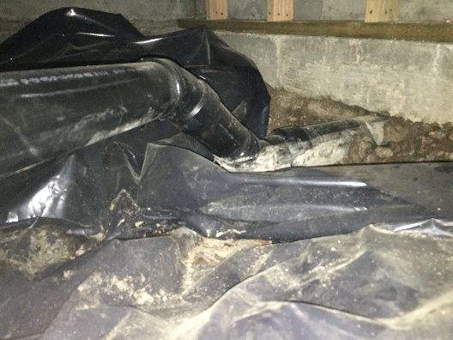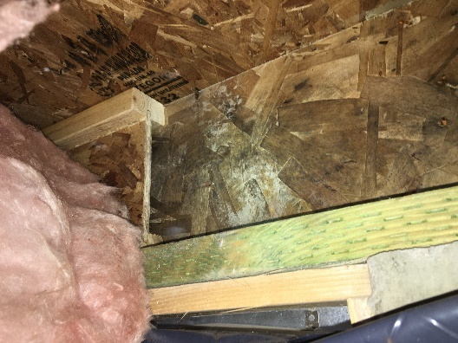
Visible evidence of repeat water intrusion Visual microbial growth on the rim joist

Douglas A. Ness (CMRS) -Idaho Contractor Registration# RCE-481
Ness, LLC gives a 10 Year Warranty on sump pump and drain system for no standing water (as per signed contract) on the crawlspace floor where drain was installed from ground water seepage and rain/snow. This Warranty is Transferable to new home buyer within warranty period. Drainage Warranty excludes water standing on the crawlspace floor from flooding that is not part of ground water seepage from irrigation or rain or due to, interior home appliances or plumbing leaks. Furthermore, Ness, LLC is not responsible for any future landscape changes that may disrupt the system. A Service Charge applies for non-warranty issues.

Douglas A. Ness (CMRS) -Idaho Contractor Registration# RCE-481
Ness LLC gives a 5-year limited warranty on no visible microbial re-growth where work is done. Warranty is void if any water or water source introduced into the area. Work under this proposal is limited to the items listed. Any additional work will need to be outlined and set out by a separate contract, or have the contract amended and signed to reflect any additional work desired.

